**Unit 1 | Assignment - KickStart My Chart**

Vanich Vacharussiriyuth

* What are three conclusions we can make about Kickstarter campaigns given the provided data?  
  + Music-related Kickstarter, which is accounted for approximately 17% of the data, has the best successful percentages. While, Theater-related Kickstarter seems to be the most popular one with a decent successful rate (60%, more than overall successful rate of 53%).  
      
    
  + December is not the best month for launching Kickstarter with the least amount of Kickstarter launched and lowest successful percentages.  
      
    
  + A significant portion of Kickstarter has a goal range between $1,000 and $5,000.  
    Kickstarter that have higher the goal (in dollars amount), tend to have a lesser chances to success but not always.  
      
    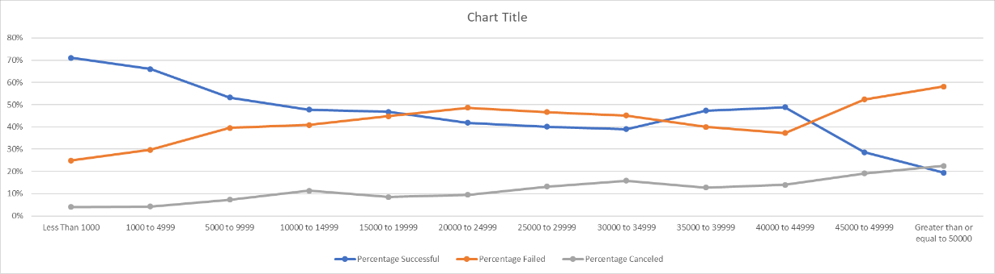
* What are some of the limitations of this dataset?
  + How quick is Kickstarter receiving pledged?
  + Forex rates – time series, if we’d like to convert all the funding to USD.
  + How skewed is the funding in each Kickstarter? For instance, some project might be pledged by 50 backers but 5 of them accounted for 75% of funding.
* What are some other possible tables/graphs that we could create?
  + Time frame of Kickstarter (Launch - Deadline) vs Successful percentages
  + Time frame of Kickstarter (Launch - Deadline) vs Category/Sub-category
  + Pie Chart of numbers of Kickstarter in each country with successful percentages
  + Average donations per Category/Sub-category vs Successful percentages